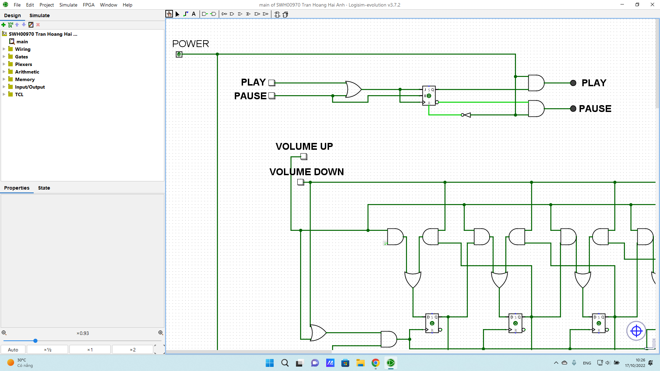

The first stage I used OR gate to take 2 inputs then output to J and Clock. I also connected J and Clock but also K to get the output connected to AND gate before Pause. So when I press Play, It turns on Play Led, otherwise it turns on pause led. I add an AND gate before LED to make sure the Led will turn off if Power is off

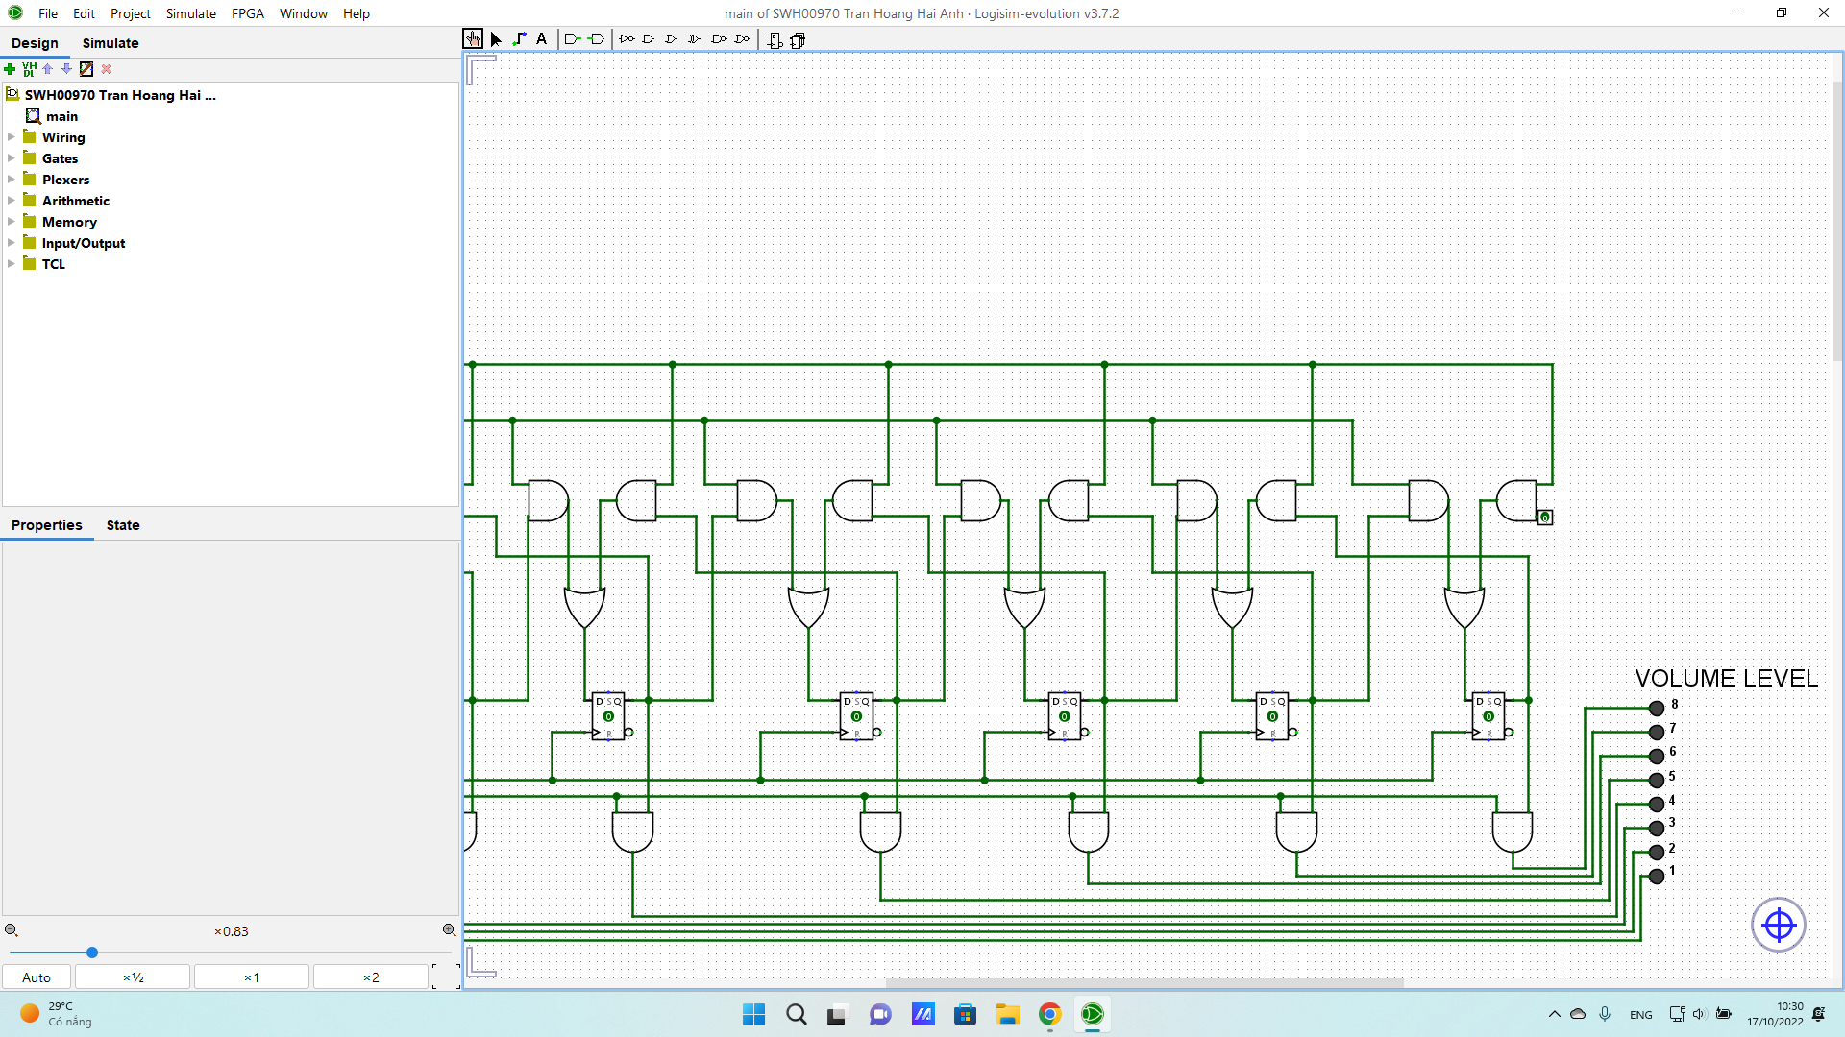

The volume part i basically use stacks from 4 week combined with AND gates before LED for power on and off part which is asked on the 4 stage

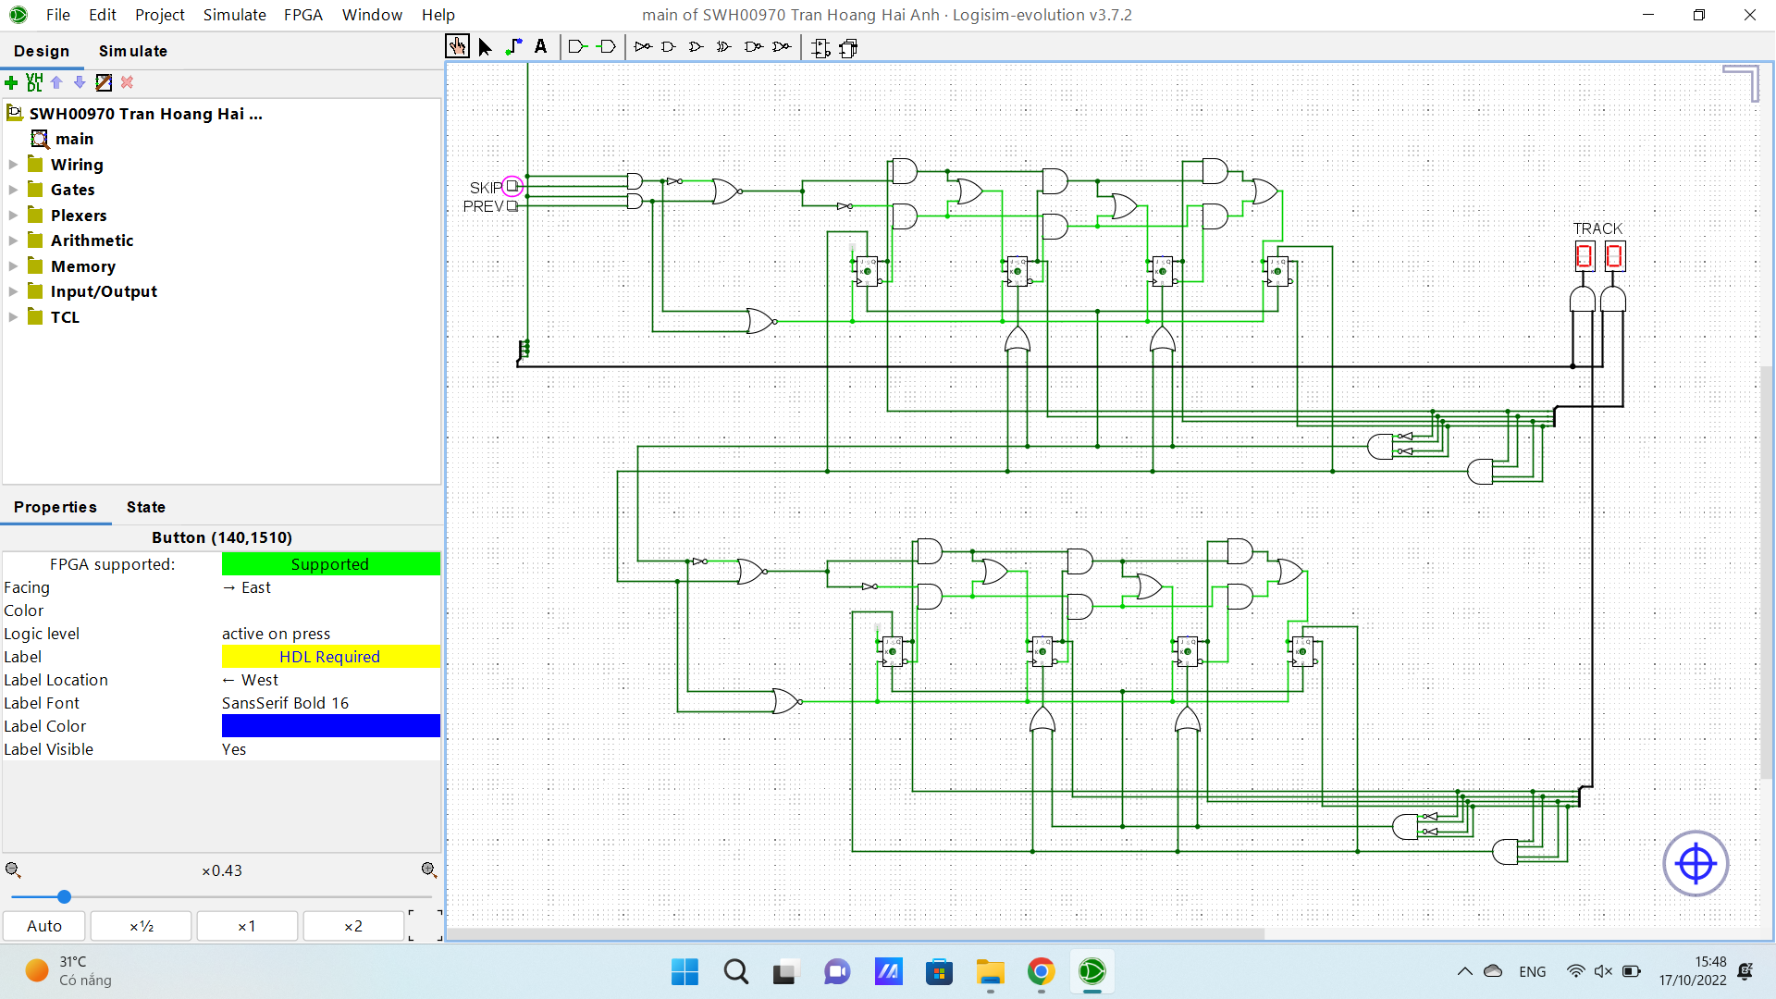

The track counter which I used were JK flip flops ripple counter with a selector for bi directional counting. I connected the Set and Reset in order to count back to 0 when it reaches 10 or count back to 9 after clicking PREV from 0. I connect those wires through a splitter on the right to merge signals from 4 wires. It is used to display HEX numbers. The AND gate with 4 inputs with 2 NOT gates is used for reset when clicking SKIP. The AND gate with 4 inputs with 0 NOT gates is used for reset when clicking PREV. I connected 4 flip flops to another 4 flip flops to count more than 9. So every time it hits 9 then reset to 0 on the first set of flip flops it converts to a signal to the second flip flop. Before each hex displays, I connected through an AND gate and a splitter to ensure when I turn off the power, the track counter returns to 0. Splitter is required as I need to merge the signal from POWER above to the HEX displayer.